[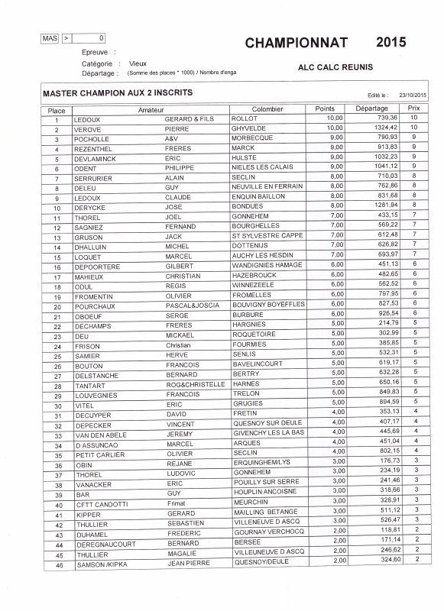](http://pigeonsportpassions.skyrock.com/photo.html?id_article=3263548810&id_article_media=56661121)